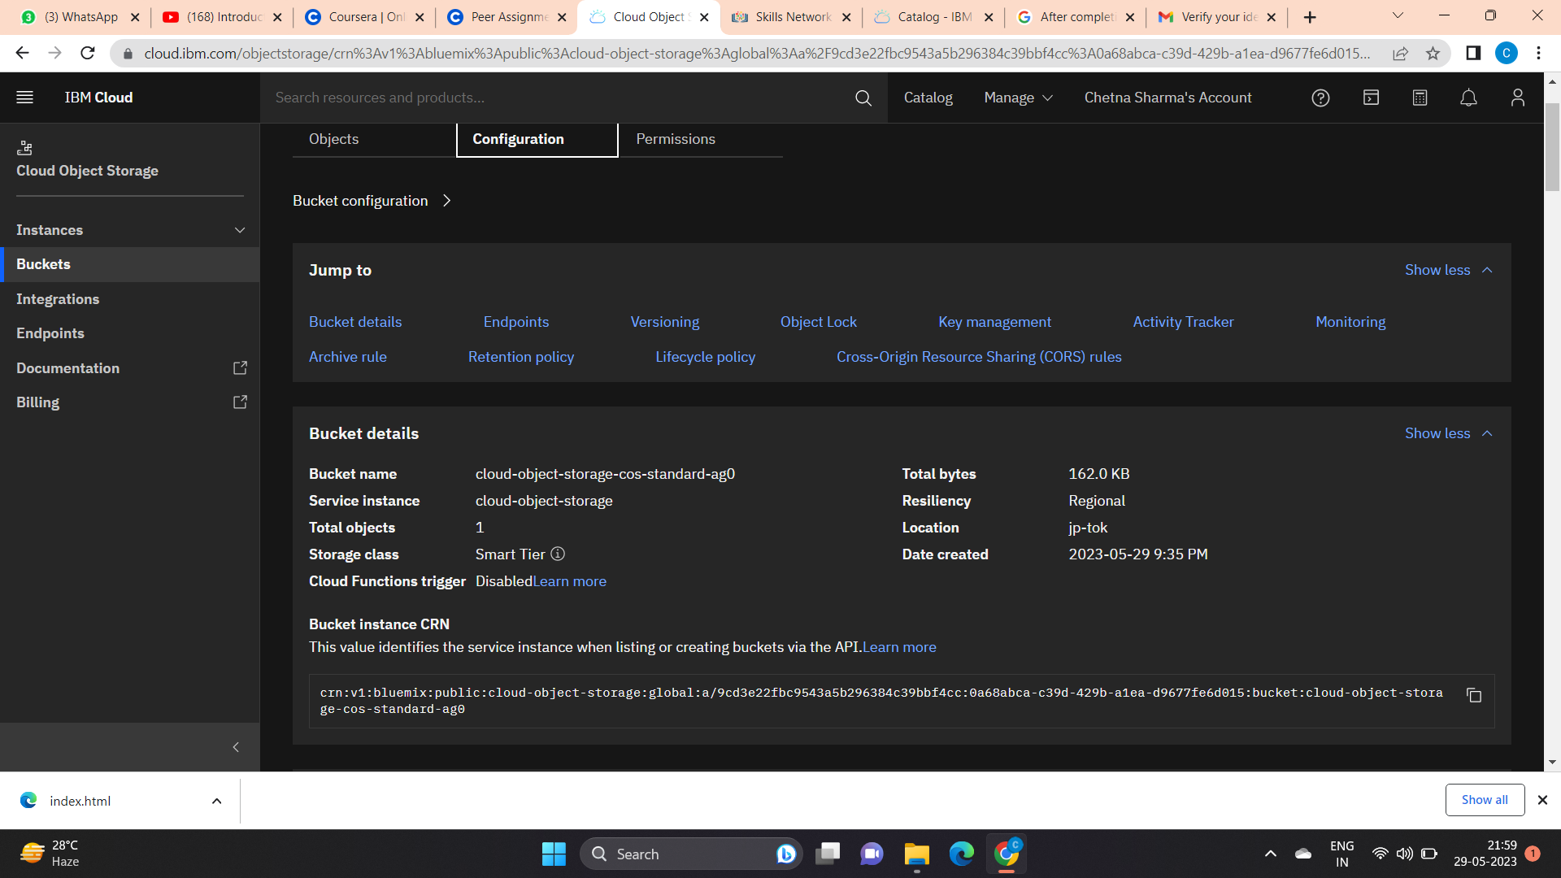

This is an effective way to store data without any limit . It is an example of creating instance of objects storage in buckets on IBM cloud platform.